**Practical No: 6**

**Aim:Demo of Decision Tree.**

**Theory**: A decision tree is a flowchart-like tree structure where an internal node represents feature(or attribute), the branch represents a decision rule, and each leaf node represents the outcome. The topmost node in a decision tree is known as the root node. It learns to partition on the basis of the attribute value. It partitions the tree in recursively manner call recursive partitioning. This flowchart-like structure helps you in decision making. It's isualization like a flowchart diagram which easily mimics the human level thinking. That is why decision trees are easy to understand and interpret.

**Code:**

Step1: click on packages and set cran mirror.

Step2: click on packages and select install packages and install 3 packages (rpart,tree,rattle)

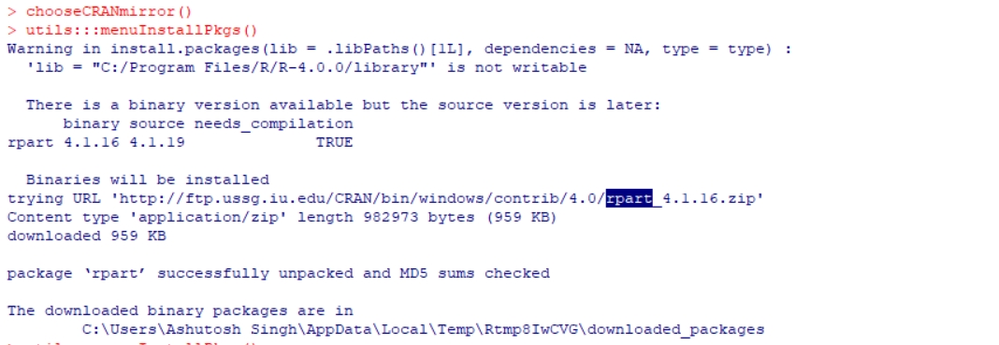

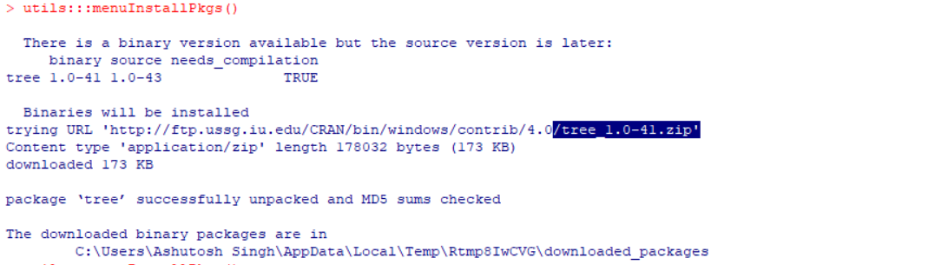

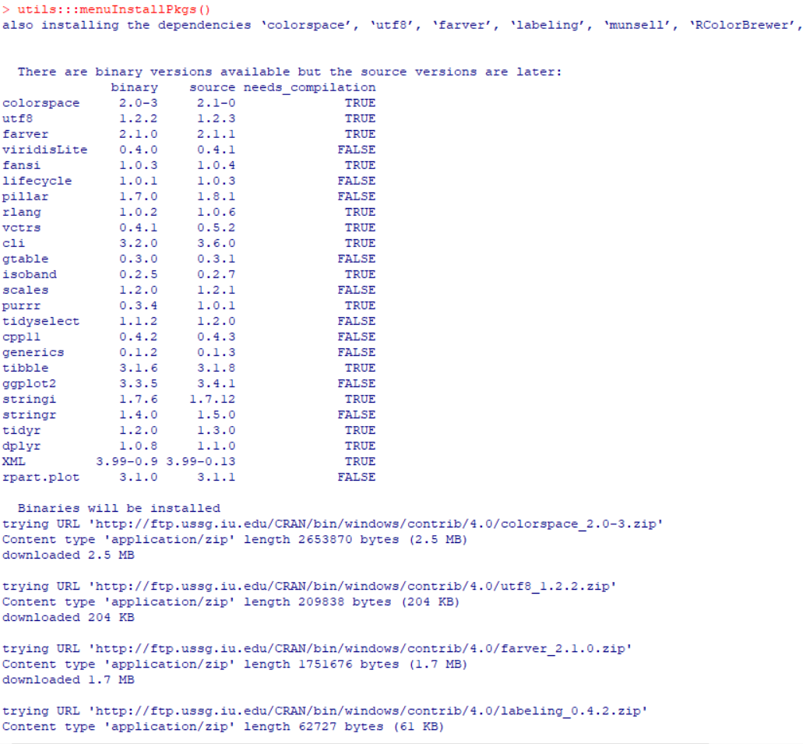

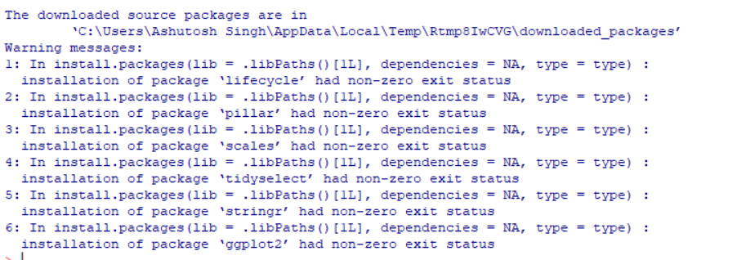

* **Create an excel data save it with .csv extension.**

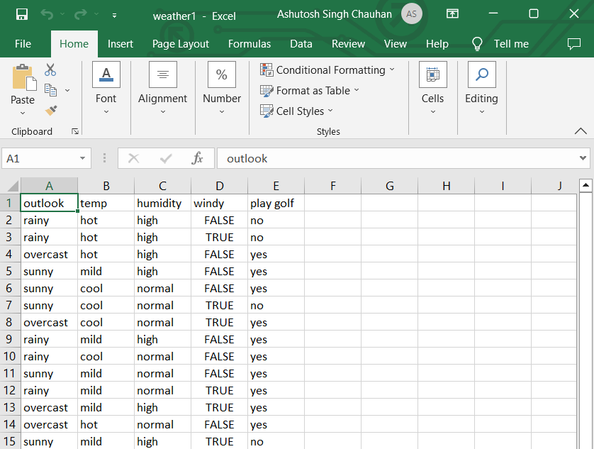

**Read excel data**

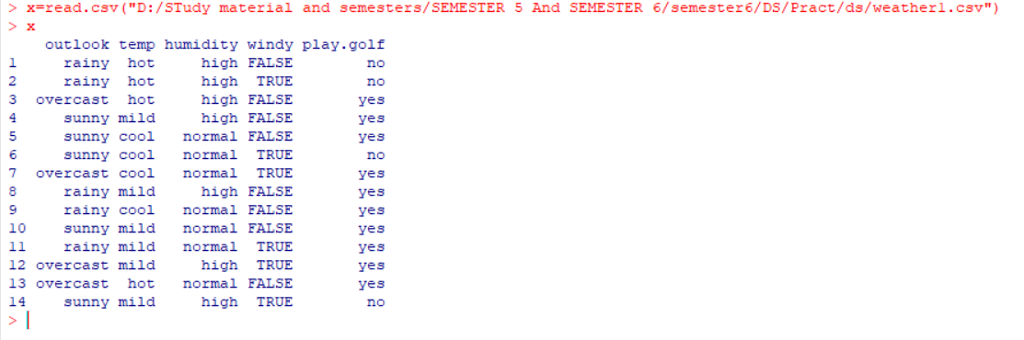

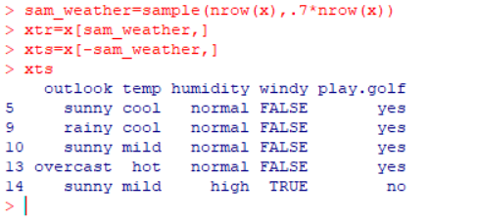

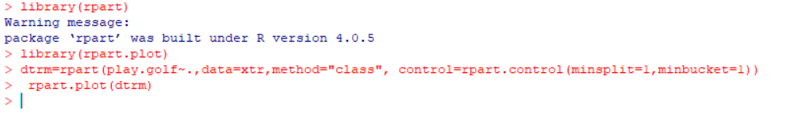

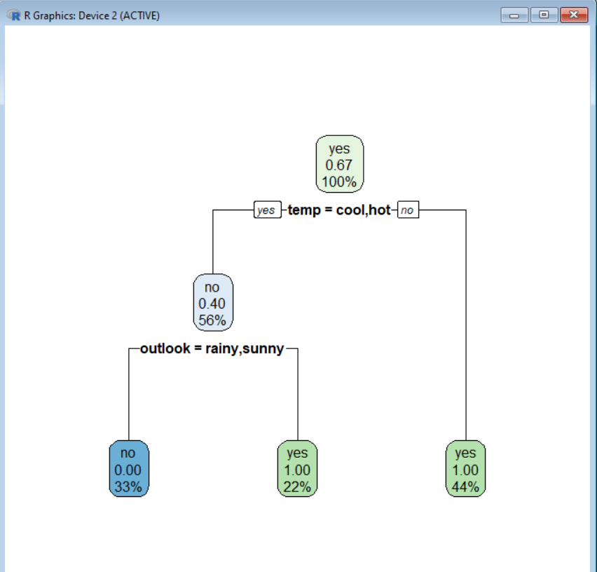

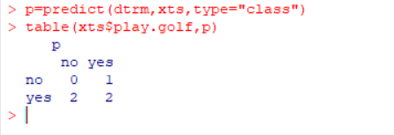

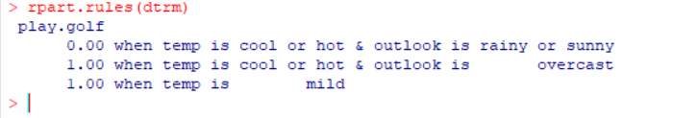 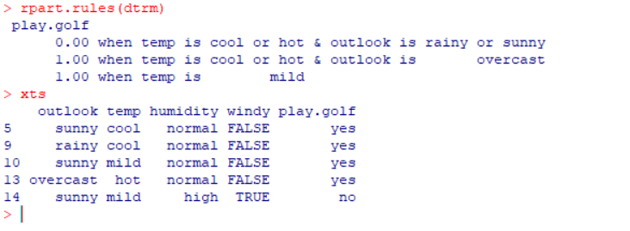

**Regression Tree:**

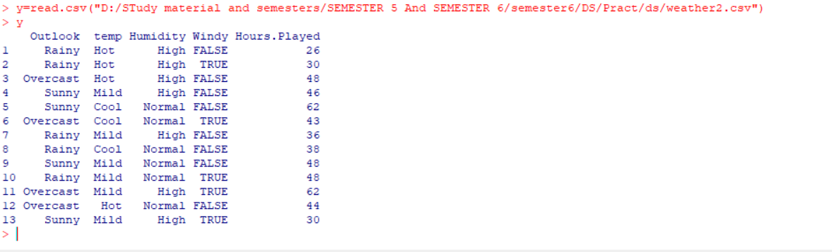

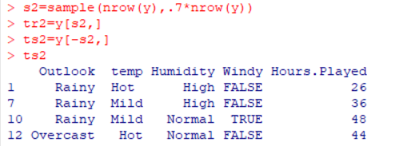

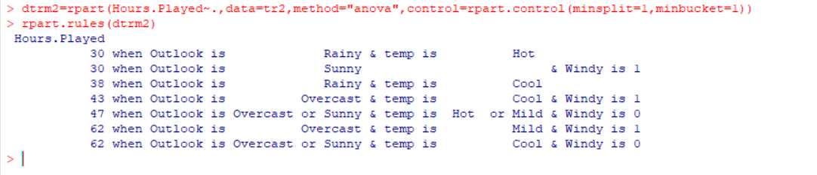



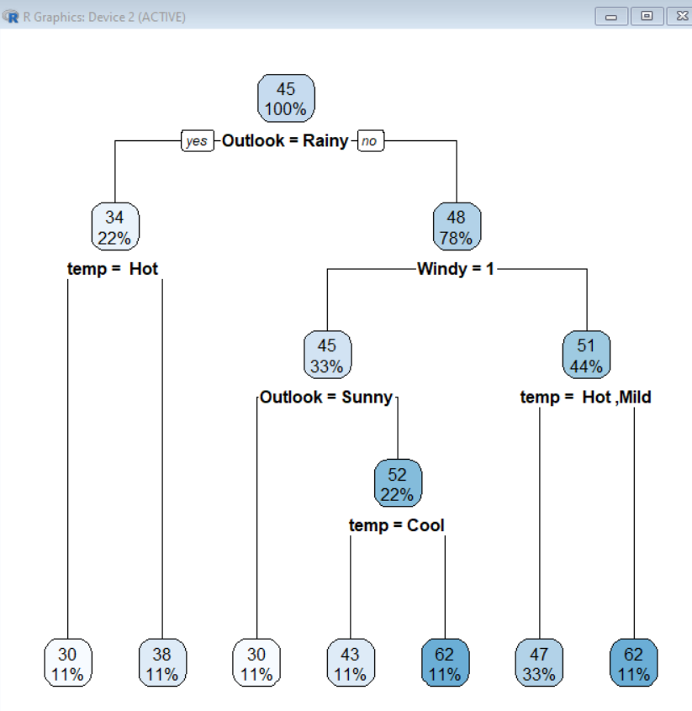

**Prediction:**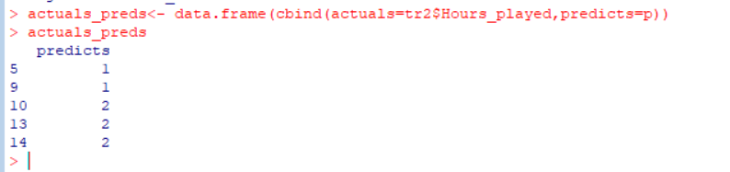

**Conclusion:** Successfully Implemented Decision Tree…